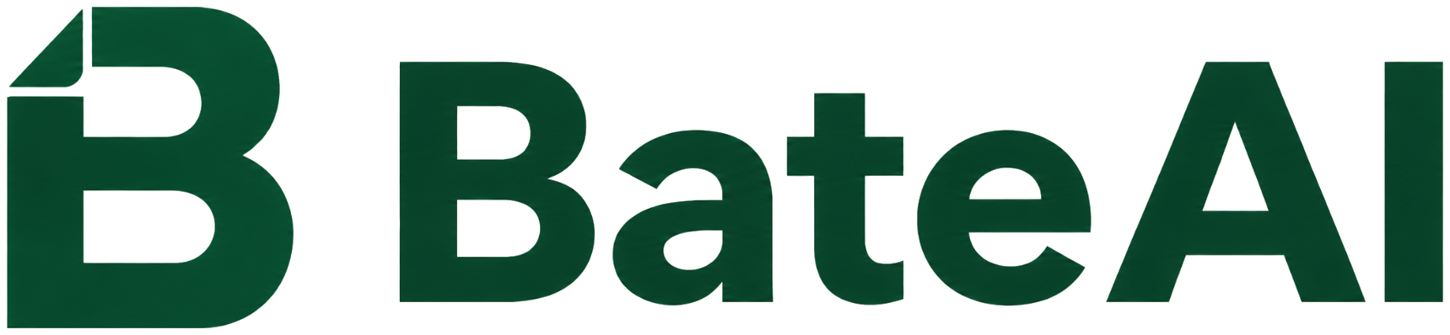

AI Policy Template for Company Use
Practical baseline for AI usage rules, employee acknowledgements, AI literacy evidence, tool inventory, risk baseline and Evidence Pack.
How to use this template
This document is a starting point for internal adaptation. Add your approved tools, roles, data rules, approval process and contacts. It is not legal advice, certification or a compliance guarantee.

1. Document metadata
Field | Value
Organization | [COMPANY NAME]
Policy version | v1.0
Effective date | [YYYY-MM-DD]
Policy owner | [Name / role]
Approver | [Management / IT / Security / HR]
Scope | [employees / contractors / suppliers]
Review cadence | [e.g. every 6–12 months or after major tool changes]

2. Purpose and principles
The purpose of this AI policy is to define clear rules for using AI tools at work: what is allowed, what is restricted, how data is protected and how evidence is maintained.
- Use AI responsibly, transparently and with human review.
- Do not input confidential, sensitive or personal data into AI tools without approval.
- Use approved AI tools according to the inventory and internal rules.
- Maintain evidence: policy version, ACK, training records, tool inventory, risk baseline and audit trail.

3. Scope and definitions
This policy applies to work-related use of generative and assistive AI tools, including text, documents, code, images, data analysis and internal workflows.

4. Roles and responsibilities
Assign clear ownership for policy approval, tool inventory, training evidence, ACK collection, incident reporting and review.

5. Allowed, restricted and prohibited use
Define examples of allowed use, restricted use and prohibited use. Prohibited use normally includes confidential client data, personal data, credentials, trade secrets and automated decisions affecting people unless explicitly approved.

6. Data handling rules
If in doubt, treat data as confidential. Minimize data inputs, remove identifiers and use only approved tools for internal or customer data.

7. AI tools inventory and approvals
Maintain an inventory of AI tools with status, owner, purpose, data rules, users and review date. New tools should be reviewed before use.

8. AI literacy training and ACK
Employees who use AI tools for work should complete AI literacy training and acknowledge the current AI policy. Keep evidence of training completion and acknowledgements.

9. Risk baseline and exceptions
Maintain a lightweight risk baseline for main AI use cases and tools. Record risks, mitigations, review status and approved exceptions.

10. Incidents and reporting
Report suspected data leaks, unsafe outputs, use of unapproved tools or policy breaches to [CONTACT / CHANNEL]. Record what happened, when, impact and actions taken.

11. Audit trail and Evidence Pack
For customer, security or internal review, maintain exportable evidence that maps question → suggested answer → evidence → limitation.
- Current policy and version history.
- ACK summary: who acknowledged the policy and when.
- AI literacy evidence: training completion and coverage.
- AI tools inventory: tool, status, owner and data rules.
- Risk baseline: key risks, mitigations and review status.
- Audit trail: key governance actions over time.
- Manifest + file checksums for export verification.

Appendix A: Employee quick checklist
- I use only approved or permitted AI tools.
- I do not input sensitive, confidential or personal data without approval.
- I review AI outputs before using them.
- If unsure, I ask the policy owner, IT or security.
- I report incidents without unnecessary delay.

Appendix B: Acknowledgement text
ACK text
I confirm that I have read and understood the current AI policy and will follow the rules for using AI tools at work. Name / date / policy version / signature or electronic acknowledgement.
© Bate AI Control s.r.o. · Template for internal adaptation. Evidence Pack is not a compliance certification or legal audit.

